Azure Board : Tool in AZ Devops used to plan Team and work to be done., It is mimic of Jira.

Boards have multiple process : Basic, Agile, Scrum , CMMI, we can create new Process by inherit

Basic

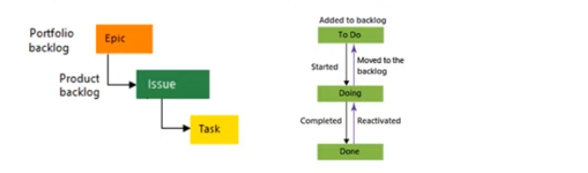

Agile Process

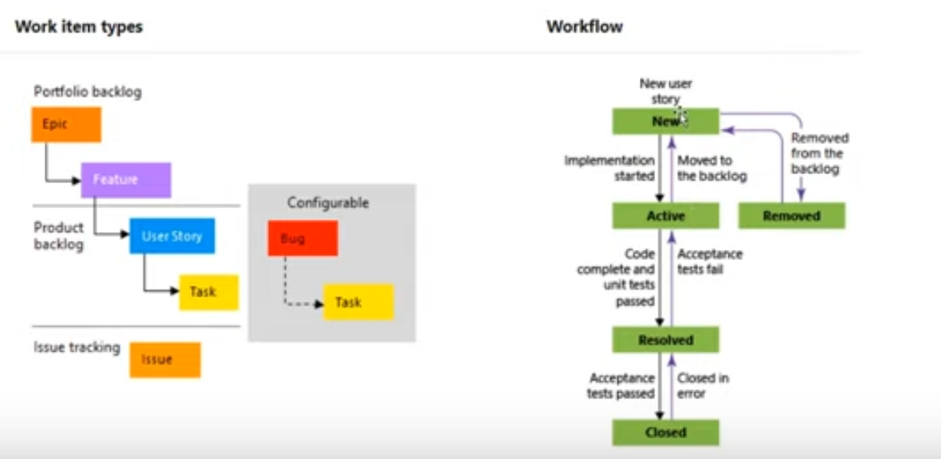

|  |  |  |  |  |
| --- | --- | --- | --- | --- |
| i | Type | Title | State | Parent Type |
| 1 | Epic | Shopping Cart | Resolved |  |
| 2 | Epic | Loyalty Membership | Active |  |
| 3 | Epic | Customer Management | New |  |
| 4 | Epic | Payment | New |  |
| 5 | Epic | Vendor Management | New |  |
| 6 | Feature | Product Catalog | Resolved | 1 |
| 7 | Feature | Price Catalog | Active | 1 |
| 8 | Feature | Member Signup | New | 2 |
| 9 | Feature | Purchase | New | 4 |
| 10 | Feature | Loyalty Points | New | 2 |
| 11 | User Story | As a user I want to view products in certain category | Closed | 6 |
| 12 | User Story | As a user I want to add items to my shopping cart | Active | 6 |
| 13 | User story | As user , I want to view Product details | Closed | 6 |
| 14 | Task | As a user, I want to view public information as static as JS | Closed |  |
| 15 | Task | List of recommended products as per categories on landing page | Closed | 6 |
|  |  |  |  |  |
|  |  |  |  |  |

